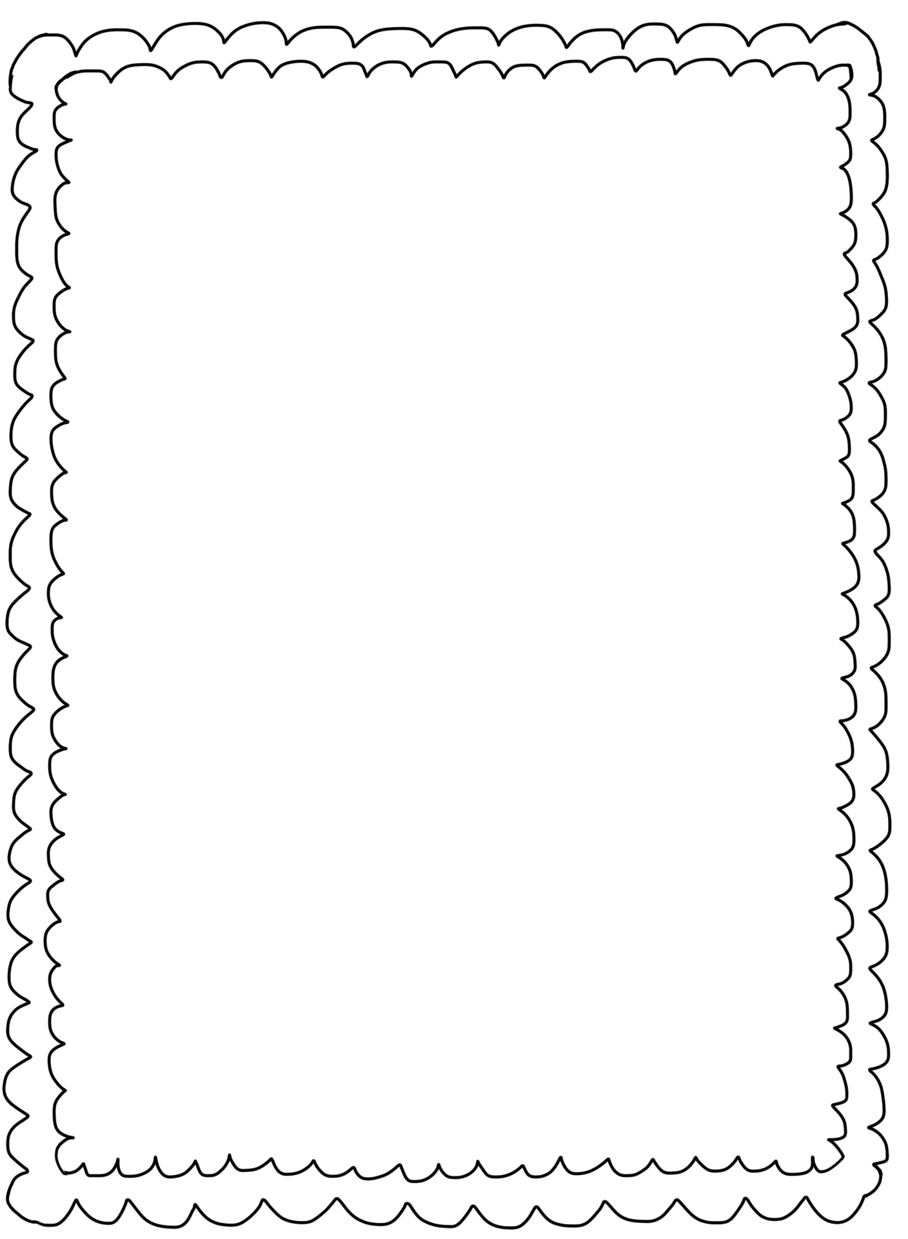

* Gallon Ziplock Baggies
* Kleenex
* Tempera Paints 16 oz.
* Small boxes of Crayons
* Elmer’s glue sticks (No scented)
* Expo black dry erase markers
* 2 packages of Playdoh brand playdoh (no mini’s)
* Pencils
* Washable Crayola markers
* Small toys for treasure box
* 1 Paper towel
* 1 Box of Clorox Wipes
* Large Hand Sanitizer bottle
* Color copy paper or cardstock copy paper

Thanks/Gracias,

Kinder Team

Thank you!

Kinder Supplies